N A M COLLEGE KALLIKKANDY

VIDYAGIRI-670693



MEDIMATE
By

ATHEENA S.S NM21CCSR24
ABHIRAM K.P NM21CCSR27
RISANA SHERIN K.P NM21CCSR16

Under The Guidance Of
(capt)DR. SHAMEER A.P

Project Report
Submitted to the NAM College KALLIKKANDY in partial fulfilment of the requirements
For the award of the degree
B.Sc. COMPUTER SCIENCE

N A M COLLEGE KALLIKKANDY

KANNUR DIST-670693

CERTIFICATE

This is to certify that the project entitled “MEDIMATE” prepared by ATHEENA SS , ABHIRAM K.P, RISANA SHERIN K.P is a bonafide record of work done by them towards the partial fulfilment for the award of Bachelor of Degree in Computer Science under the university of Kannur during the period 2023-2024.

Signature of lecturer in charge Signature of Head of the Dept.

Submitted for the University examination Examiners:
1.
2.

ACKNOWLEDGEMENT
We have immense pleasure in acknowledging the service and cooperation rendered by umpteen people in their non-fields and ways. The success of any task accomplished lies not only in hands of the accomplisher but also the guiding light offered by all those around, towards the road to success , they did much to shape up the success.
We are grateful to our college Principal Dr. MAJEESH T for extending facilities required throughout our project work.
We wish to express our deepest sense of gratitude to our guide Mr. Shameer sir & Mr. Muhammed Shafi Sir, Mr. Haseeb Sir, Ms. Mini Mol Miss, Ms. Saida Miss whose generous support, constant encouragement and healthy criticism have been invaluable help to us throughout the course of this project.
Last but not least We also express our heartfelt thanks to our classmates for providing valuable suggestions which make this endeavor a success.

 | TABLE OF CONTENTS
Serial  No | TOPIC | Page No
1 | ABSTRACT | 6
2 | INTRODUCTION | 7
2.1 INTROUDUCTION TO THE SYSTEM
2.2 ABOUT THE PROJECT
3 | PROBLEM FORMULATION | 8
3.1 OBJECTIVES
3.2 PROBLEM STATEMENT
3.3 SOFTWARE USED
3.4 PLATFORM REQUIREMENTS
4 | SYSTEM ANALYSIS | 27
4.1 PRESENT SYSTEM
4.2 PROPOSED SYSTEM
4.3 USE CASE ANALYSIS
4.4 FEASIBILITY ANALYSIS
5 | SYSTEM DESIGN | 32
5.1 INTRODUCTION
5.2 FUNDAMENTAL DESIGN CONCEPT
5.3 INPUT DESIGN
5.4 OUTPUT DESIGN
5.5 DATABASE DESIGN
5.6 TABLES
5.7 CONCEPTUAL SYSTEM DESIGN
5.8 VALIDATION AND CHECKS
6 | SYSTEM DEVELOPMENT | 48
7 | SYSTEM CODING AND TESTING | 49

7.1 SYSTEM TESTING
7.2 LEVELS OF TESTING
7.3 TESTING THE SYSTEM
 | 8 | SYSTEM IMPLEMENTATION | 53
 | 9 | FORMS | 55
 | 10 | CONCLUSION | 64
 | 11 | FUTURE SUGGESTION | 65
 | 12 | BIBLOGRAPHY | 66

1.ABSTRACT
The main challenge faced by patients in government hospitals is the significant queue for OP ticketing, requiring prolonged waits.
Our proposed solution is an online OP management system designed to eliminate this wait time. We suggest a mobile application enabling users to explore available doctors and book OP tickets seamlessly. After selecting a doctor and booking an OP, a QR code will be generated. Scan this QR at the hospital, and the OP ticket will be issued. Additionally, our system offers a feature for laboratory services: digital copies of test results will be sent to the app, ensuring safe storage for potential future needs. So this projec help people to avoid the long waits for OP ticketing as well as the lab test results. The system has the potential to improve the patient experience in government hospitals.
The project is going to be developed in HTM, CSS, JAVASCRIPT as front end and MYSQL as back end. Since the software is flexible and interactive even non-professionals can also handle the system easily .

INTRODUCTION

2.1 INTRODUCTION

In the realm of healthcare, accessibility, and efficiency are paramount to ensuring the well-being of individuals seeking medical attention. Government hospitals, while crucial in providing healthcare to a wide demographic, often grapple with challenges such as prolonged waiting times for Outpatient (OP) ticketing. Recognizing this issue, our project endeavors to revolutionize the patient experience through the implementation of an innovative Online OP Management System.

Our proposed solution leverages modern technology to streamline the OP ticketing process, significantly reducing wait times for patients. The cornerstone of our approach is a user-friendly mobile application that empowers individuals to seamlessly explore available doctors, book OP tickets, and manage their healthcare appointments effortlessly. By integrating a QR code system, our solution not only expedites the check-in process at the hospital but also enhances overall operational efficiency.

Furthermore, our system extends its benefits beyond mere appointment scheduling. We have incorporated a feature dedicated to laboratory services, ensuring that patients receive digital copies of their test results directly on the mobile application. This not only facilitates the secure storage of crucial medical information but also caters to the evolving needs of patients in an increasingly digitized healthcare landscape.

Through this project, we aim to bridge the gap between healthcare providers and patients, fostering a more accessible, efficient, and patient-centric healthcare experience in government hospitals.

2.1 INTRODUCTION

In the realm of healthcare, accessibility, and efficiency are paramount to ensuring the well-being of individuals seeking medical attention. Government hospitals, while crucial in providing healthcare to a wide demographic, often grapple with challenges such as prolonged waiting times for Outpatient (OP) ticketing. Recognizing this issue, our project endeavors to revolutionize the patient experience through the implementation of an innovative Online OP Management System.

Our proposed solution leverages modern technology to streamline the OP ticketing process, significantly reducing wait times for patients. The cornerstone of our approach is a user-friendly mobile application that empowers individuals to seamlessly explore available doctors, book OP tickets, and manage their healthcare appointments effortlessly. By integrating a QR code system, our solution not only expedites the check-in process at the hospital but also enhances overall operational efficiency.

Furthermore, our system extends its benefits beyond mere appointment scheduling. We have incorporated a feature dedicated to laboratory services, ensuring that patients receive digital copies of their test results directly on the mobile application. This not only facilitates the secure storage of crucial medical information but also caters to the evolving needs of patients in an increasingly digitized healthcare landscape.

Through this project, we aim to bridge the gap between healthcare providers and patients, fostering a more accessible, efficient, and patient-centric healthcare experience in government hospitals.

2.2 ABOUT THE PROJECT
In the dynamic landscape of healthcare, where accessibility and efficiency are paramount, we present MediMate – a pioneering solution aimed at redefining the patient experience in government hospitals. Our innovative Online OP Management System, encapsulated within the user-friendly MediMate mobile application, empowers individuals to effortlessly navigate doctor availability, book OP tickets, and manage appointments seamlessly. Featuring a cutting-edge QR code system, MediMate expedites hospital check-ins, effectively slashing wait times. Beyond revolutionizing appointment scheduling, MediMate introduces a dedicated feature for laboratory services, ensuring patients receive secure digital copies of their test results. By bridging the gap between healthcare providers and patients, MediMate is at the forefront of fostering a more accessible, efficient, and patient-centric healthcare journey in government hospitals. MediMate – Your Partner in Health, Redefining Accessibility.

3.PROBLEM FORMULATION

3.1 OBJECTIVES

The main objectives of this project is to minimize the waiting time and rush infront of the OP ticketing in government hospitals by transitioning to an online system. The system enables patients to easily access healthcare services by providing a user-friendly mobile application for booking appoinments and accessing medical records.
The objective of the project is to make good software with an overall performance. The software should be easy to work. The software should be able to extract information from databases and make the reports very easily. The software is designed in such a way that the future plans of expansion can be implementing easily without affecting the existing features. The software and its operations should be safe and unauthorized access should not be allowed.
Problem definition and based on the problem definition system requirement specification is produced.
- Reduces the waiting time for opticketing.
- Enhance patient experience .
- Laboratory service integration.
This project has four modules: Administrator, Lab staff ,Doctor ,User.

1.ADMINISTRATOR
The administrator has the complete privilege to manage site. It consist of,
- LABSTAFF MANAGEMENT:
Add/edit/remove lab staff details.

- TEST MANAGEMENT:
Add/edit/remove test details.

- DOCTOR MANAGEMENT:
Add/edit/remove doctors details.
- OP TIME MANAGEMENT:
Add/view/edit optime.
- ALLOCATE DUTY DOCTOR:
Allocate/view doctors at optime.
- VIEW BOOKINGS:
View bookings at optime.
- VIEW CURRENT PATIENT:
View current patient.
- VIEW USERS:
View all users.

2.LAB STAFF
- VIEW PROFILE:
View profile of labstaff.
- VIEW TODAY TEST:
View suggested tests.
- CONFIRM TEST:
Confirm the availability of test suggested by doctor.
- UPLOAD TEST RESULT:
Upload test result of suggested tests.

3.DOCTOR
- VIEW PROFILE:
View profile of doctor.
- VIEW DUTY:
View allocated duty.
- VIEW PATIENT:
View patient details.
- UPDATE PATIENT EXIT:
Update when current patient exits.
- SUGGEST LAB TEST:
Suggest lab test for patient.
- VIEW PREVIOUS HISTORY:
View patient history.

4.USERS:
- REGISTER:
Register in the application to access the facilities.
- VIEW PROFILE:
View profile of user.
- SCAN QR & SUBMIT:
Scan the QR code and submit their details.
- VIEW TOKEN DETAILS:
View their token details.
- VIEW CURRENT TOKEN:
View current token being consulted.
- VIEW SUGGESTED TESTS:
View the test details suggested for user.
- VIEW TEST RESULTS:
View the test result uploaded by lab staff.

3.2 PROBLEM STATEMENT
DEFINITION
What is the problem to be solved?
Understanding the existing system is usually the starting activity of any project development. The goal of this activity is to understand the requirements of the new system that is to be developed. The thorough and clear understanding of the existing system involves the study of important data entities in the system, major centers where action is taken, the purpose of the different actions that are performed. There are some present computerized system existing. The existing system is not sufficient for time management and better patient experience in government hospitals.

Disadvantages of existing system
- Long queues
- Inefficiency
- Limited Accessibility
- Lack of transparency
- Loss of documents
Thus, the existing system is manual and time consuming and platform. These problems have to be solved in the proposed system and develop a pure online system.

3.3 SOFTWARE USED.
1.HTML
HTML stands for Hyper Text Mark-up Language. It is a simple text formatting language used to create hypertext documents. It is a platform independent language unlike most other programming languages. HTML is neutral and can be used on any platform or desktop. It is this feature of HTML that makes it popular as standard on the WWW. This versatile language allows the creation of hypertext links, also known as hyperlinks. These hyperlinks can be used to connect documents on different machine, on the same network or on a different network, or can even point to point of text in the same document. HTML is used for creating documents where the emphasis is on the appearance of the document. The documents created using HTML can have text with different sizes, weights and colors. It can also contain graphics to make the document more effective.

Advantages of HTML
- Easy to Learn and Use: HTML is a very simple language that anyone can understand and use.
- Web Browser Friendly: HTML works on all web browsers, making it accessible to users on any device or platform.
- User-Friendly: HTML is very user-friendly and intuitive, making it easier for developers to create websites and web applications.
- Supports Multimedia Integration: HTML supports images, audio, and video, making it a great platform for creating multimedia experiences.
- High Search Engine Visibility: HTML is very search engine-friendly, making it easier for websites to be indexed and found online.

2.CSS
Cascading Style Sheets (CSS) is a style sheet language used for specifying the presentation and styling of a document written in a markup language such as HTML or XML (including XML dialects such as SVG, MathML or XHTML). CSS is a cornerstone technology of the World Wide Web, alongside HTML and JavaScript.
CSS is designed to enable the separation of content and presentation, including layout, colors, and fonts.] This separation can improve content accessibility, provide more flexibility and control in the specification of presentation characteristics; enable multiple web pages to share formatting by specifying the relevant CSS in a separate . css file, which reduces complexity and repetition in the structural content; and enable the .css file to be cached to improve the page load speed between the pages that share the file and its formatting.
Separation of formatting and content also makes it feasible to present the same markup page in different styles for different rendering methods, such as on-screen, in print, by voice (via speech-based browser or screen reader), and on Braille-based tactile devices. CSS also has rules for alternate formatting if the content is accessed on a mobile device
The CSS specifications are maintained by the World Wide Web Consortium (W3C). Internet media type (MIME type) is registered for use with CSS by RFC 2318 (March 1998). The W3C operates a free CSS validation service for CSS documents. In addition to HTML, other markup languages support the use of CSS including XHTML, plain XML, SVG, and XUL. CSS is also used in the GTK widget toolkit.
Features of CSS

Separation of content from presentation: CSS facilitates the publication of content in multiple presentation formats based on nominal parameters.

Site-wide consistency: When CSS is used effectively, in terms of inheritance and "cascading", a global style sheet can be used to affect and style elements site-wide.

Bandwidth: A stylesheet, internal or external, specifies the style once for a range of HTML elements selected by class, type or relationship to others.

Page reformatting: With a simple change of one line, a different style sheet can be used for the same page.

Accessibility: Without CSS, web designers must typically lay out their pages with techniques such as HTML tables that hinder accessibility for vision-impaired users.

3.JAVASCRIPT
JavaScript often abbreviated as JS, is a programming language and core technology of the World Wide Web, alongside HTML and CSS. As of 2024, 98.9% of websites use JavaScript on the client side for webpage behavior,] often incorporating third-party libraries. All major web browsers have a dedicated JavaScript engine to execute the code on users' devices.
JavaScript is a high-level, often just-in-time compiled language that conforms to the ECMAScript standard. It has dynamic typing, prototype-based object-orientation, and first-class functions. It is multi-paradigm, supporting event-driven, functional, and imperative programming styles. It has application programming interfaces (APIs) for working with text, dates, regular expressions, standard data structures, and the Document Object Model (DOM).
Features of JS
- Light Weight Scripting language: JavaScript is a lightweight scripting language because it is made for data handling in the browser or the client side.
- Dynamic Typing: JavaScript supports dynamic typing which means types of the variable are defined based on the stored value.
- Object-oriented programming support: The concept of class and OOP is better defined.
- Functional Style: This implies that JavaScript uses a functional approach, even objects are created from the constructor functions and each constructor function represents a unique object type.
- Platform Independent: This implies that JavaScript is platform-independent or we can say it is portable.
- Prototype-based:This means JavaScript uses prototypes instead of classes or inheritance.
- Interpreted Language : JavaScript is an interpreted language which means the script written inside JavaScript is processed line by line.

4.XML
Extensible Markup Language (XML) is a markup language and file format for storing, transmitting, and reconstructing arbitrary data. It defines a set of rules for encoding documents in a format that is both human-readable and machine-readable. The World Wide Web Consortium's XML 1.0 Specification] of 1998 and several other related specifications]—all of them free open standards—define XML.
The design goals of XML emphasize simplicity, generality, and usability across the Internet It is a textual data format with strong support via Unicode for different human languages. Although the design of XML focuses on documents, the language is widely used for the representation of arbitrary data structures such as those used in web services.
Several schema systems exist to aid in the definition of XML-based languages, while programmers have developed many application programming interfaces (APIs) to aid the processing of XML data.
Features of XML
- Excellent for handling data with a complex structure or atypical data.
- Data described using markup language.
- Text data description.
- Human- and computer-friendly format.
- Handles data in a tree structure having one-and only one-root element.
- Excellent for long-term data storage and data reusability.

5.DJANGO
Django is a free and open-source, Python-based web framework that runs on a web server. It follows the model–template–views (MTV) architectural pattern. It is maintained by the Django Software Foundation (DSF), an independent organization established in the US as a 501(c)(3) non-profit.
Django's primary goal is to ease the creation of complex, database-driven websites. The framework emphasizes reusability and "pluggability" of components, less code, low coupling, rapid development, and the principle of don't repeat yourself.] Python is used throughout, even for settings, files, and data models. Django also provides an optional administrative create, read, update and delete interface that is generated dynamically through introspection and configured via admin models.
Some well-known sites that use Django include Instagram, Mozilla, Disqus, Bitbucket, Nextdoor and Clubhouse.
- Portable: Since Django is a Python-based web framework it runs on almost all platforms
- Speed: Frameworks are usually developed to make the application development process easier and faster without having to write code from scratch to even simple things.
- Security: Django has inbuilt standard encryption packages required to secure the website
- Thoroughly Tested: Frameworks usually have a low user base and aren’t adopted by a large community, unlike Programming Languages.
- Scalability: Django can handle large amounts of traffic and provide API Usage to around 450+ million users
- Superior Framework Documentation: When it comes to languages and frameworks, they evolve on a regular basis. It is also hard to find a textbook for a framework since publishers can’t release new editions regularly.

6.MYSQL
MySQL is an open-source relational database management system (RDBMS) Its name is a combination of "My", the name of co-founder Michael Widenius's daughter My, and "SQL", the acronym for Structured Query Language. A relational database organizes data into one or more data tables in which data may be related to each other; these relations help structure the data. SQL is a language that programmers use to create, modify and extract data from the relational database, as well as control user access to the database. In addition to relational databases and SQL, an RDBMS like MySQL works with an operating system to implement a relational database in a computer's storage system, manages users, allows for network access and facilitates testing database integrity and creation of backups.
MySQL is free and open-source software under the terms of the GNU General Public License, and is also available under a variety of proprietary licenses. MySQL was owned and sponsored by the Swedish company MySQL AB, which was bought by Sun Microsystems (now Oracle Corporation) In 2010, when Oracle acquired Sun, Widenius forked the open-source MySQL project to create MariaDB.
MySQL has stand-alone clients that allow users to interact directly with a MySQL database using SQL, but more often, MySQL is used with other programs to implement applications that need relational database capability. MySQL is a component of the LAMP web application software stack (and others), which is an acronym for Linux, Apache, MySQL, Perl/PHP/Python. MySQL is used by many database-driven web applications, including Drupal, Joomla, phpBB, and WordPress MySQL is also used by many popular websites, including Facebook Flickr, MediaWiki, Twitter, and YouTube.
FEATURS OF MYSQL
- Relational Database Management System (RDBMS): MySQL is a relational database management system. This database language is based on the SQL queries to access and manage the records of the table.
- Easy to use: MySQL is easy to use. We have to get only the basic knowledge of SQL. We can build and interact with MySQL by using only a few simple SQL statements.
- Speed: MySQL is considered one of the very fast database languages, backed by a large number of the benchmark test.
- Memory efficiency: Its efficiency is high because it has a very low memory leakage problem.
- High Productivity: MySQL uses Triggers, Stored procedures, and views that allow the developer to give higher productivity
- Platform Independent: It can download, install, and execute on most of the available operating systems.
- Partitioning: This feature improves the performance and provides fast management of the large database.
- Compatible on many operating systems: MySQL is compatible to run on many operating systems, like Novell NetWare, Windows* Linux*, many varieties of UNIX* (such as Sun* Solaris*, AIX, and DEC* UNIX), OS/2, FreeBSD*, and others.

7.JAVA
Java is a high-level, class-based, object-oriented programming language that is designed to have as few implementation dependencies as possible. It is a general-purpose programming language intended to let programmers write once, run anywhere (WORA), meaning that compiled Java code can run on all platforms that support Java without the need to recompile. Java applications are typically compiled to bytecode that can run on any Java virtual machine (JVM) regardless of the underlying computer architecture. The syntax of Java is similar to C and C++, but has fewer low-level facilities than either of them. The Java runtime provides dynamic capabilities (such as reflection and runtime code modification) that are typically not available in traditional compiled languages.
Java was originally developed by James Gosling at Sun Microsystems. It was released in May 1995 as a core component of Sun's Java platform. The original and reference implementation Java compilers, virtual machines, and class libraries were originally released by Sun under proprietary licenses. As of May 2007, in compliance with the specifications of the Java Community Process, Sun had relicensed most of its Java technologies under the GPL-2.0-only license. Oracle offers its own HotSpot Java Virtual Machine, however the official reference implementation is the OpenJDK JVM which is free open-source software and used by most developers and is the default JVM for almost all Linux distributions.

Features of JAVA
- Simple: Java is very easy to learn, and its syntax is simple, clean and easy to understand.
- Object-oriented: Object-oriented means we organize our software as a combination of different types of objects that incorporate both data and behavior.
- Platform Independent: Java is platform independent because it is different from other languages like C, C++, etc. which are compiled into platform specific machines while Java is a write once, run anywhere language.
- Secured: Java is best known for its security. With Java, we can develop virus-free systems. Java is secured because, No explicit pointer, Java Programs run inside a virtual machine sandbox.
- Robust: The English mining of Robust is strong.
- Portable: Java is portable because it facilitates you to carry the Java bytecode to any platform. It doesn't require any implementation.
- Multi-threaded: A thread is like a separate program, executing concurrently.
- Dynamic: Java is a dynamic language. It supports the dynamic loading of classes. It means classes are loaded on demand.
- Distributed: Java is distributed because it facilitates users to create distributed applications in Java. RMI and EJB are used for creating distributed applications.

8.PYTHON
Python is a high-level, general-purpose programming language. Its design philosophy emphasizes code readability with the use of significant indentation.
Python is dynamically typed and garbage-collected. It supports multiple programming paradigms, including structured (particularly procedural), object-oriented and functional programming. It is often described as a "batteries included" language due to its comprehensive standard library.
Guido van Rossum began working on Python in the late 1980s as a successor to the ABC programming language and first released it in 1991 as Python 0.9.0. Python 2.0 was released in 2000. Python 3.0, released in 2008, was a major revision not completely backward-compatible with earlier versions. Python 2.7.18, released in 2020, was the last release of Python 2.
Python consistently ranks as one of the most popular programming languages, and has gained widespread use in the machine learning community.
FEATURES OF PYTHON
- Free and Open Source: Python language is freely available at the official website and you can download it from the given download link below click on the Download Python keyword.

- Easy to code: Python is a high-level programming language. Python is very easy to learn the language as compared to other languages like C, C#, Javascript, Java, etc.

- Object-Oriented Language: One of the key features of Python is Object-Oriented programming. Python supports object-oriented language and concepts of classes, object encapsulation, etc.

- GUI Programming Support: Graphical User interfaces can be made using a module such as PyQt5, PyQt4, wxPython, or Tk in Python.

- Easy to Debug: Excellent information for mistake tracing.

- Python is a Portable language: Python language is also a portable language.

- Interpreted Language: Python is an Interpreted Language because Python code is executed line by line at a time.

- Large Standard Library : Python has a large standard library that provides a rich set of modules and functions so you do not have to write your own code for every single thing.

- Dynamically Typed Language: Python is a dynamically-typed language. That means the type (for example- int, double, long, etc.)

9.OTHER SOFTWARES USED
1.PYCHARM
Charm is an integrated development environment (IDE) used in computer programming, specifically for the Python language. It is developed by the Czech company JetBrains (formerly known as IntelliJ). It provides code analysis, a graphical debugger, an integrated unit tester, integration with version control systems (VCSes), and supports web development with Django as well as data science with Anaconda.
FEATURES
- Coding assistance and analysis, with code completion, syntax and error highlighting, linter integration, and quick fixes
- Project and code navigation: specialized project views, file structure views and quick jumping between files, classes, methods and usages
- Python refactoring: includes rename, extract method, introduce variable, introduce constant, pull up, push down and others
- Integrated Python debugger
- Integrated unit testing, with line-by-line code coverage
- Version control integration: unified user interface for Mercurial, Git, Subversion, Perforce and CVS with change lists and merge

2.SQLYOG
SQLyog: SQLyog is the most powerful GUI tool for MySQL. SQLyog is a fast, easy to use and compact graphical tool for managing MySQL databases. SQLyog was developed for all who use MySQL as their preferred RDBMS. SQLyog makes it easy to get started and provides tools to enhance MySQL experience.
▪ Runs on all Windows version from Vista/2008 and higher
▪ Works with MySQL servers from 4.1 and higher Create/Drop/Alter Tables, Stored Procedures, Functions, Views, Triggers and Events.
▪ Formats SQL statements.
▪ Very fast retrieval of data.

3.WAMP SERVER
WampServer refers to a solution stack for the Microsoft Windows operating system, created by Romain Bourdon and consisting of the Apache web server, OpenSSL for SSL support, MySQL database and PHP programming language.
ADVANTAGE OF WAMP
- Changing settings is easy in WAMP.
- It facilitates PHP coding and database creation on the Windows platform.
- It is available for 64 and 32-bit systems.

4.Adobe Dreamweaver

Adobe Dreamweaver is a proprietary web development tool from Adobe Inc. It was created by Macromedia in 1997 and developed by them until Macromedia was acquired by Adobe Systems in 2005.]
Adobe Dreamweaver is available for the macOS and Windows operating systems.
Following Adobe's acquisition of the Macromedia product suite, releases of Dreamweaver subsequent to version 8.0 have been more compliant with W3C standards. Recent versions have improved support for Web technologies such as CSS, JavaScript, and various server-side scripting languages and frameworks including ASP (ASP JavaScript, ASP VBScript, ASP.NET C#, ASP.NET VB), ColdFusion, Scriptlet, and PHP.

5.ANDROID STUDIO
Android Studio is the official] integrated development environment (IDE) for Google's Android operating system, built on JetBrains' IntelliJ IDEA software and designed specifically for Android development. It is available for download on Windows, macOS and Linux based operating systems. It is a replacement for the Eclipse Android Development Tools (E-ADT) as the primary IDE for native Android application development.
Android Studio was announced on May 16, 2013, at the Google I/O conference. It was in early access preview stage starting from version 0.1 in May 2013, then entered beta stage starting from version 0.8 which was released in June 2014. The first stable build was released in December 2014, starting from version 1.0. At the end of 2015, Google dropped support for Eclipse ADT, making Android Studio the only officially supported IDE for Android development.
FEATURES
- Gradle-based build support
- Android-specific refactoring and quick fixes
- Lint tools to catch performance, usability, version compatibility and other problems
- ProGuard integration and app-signing capabilities
- Template-based wizards to create common Android designs and components
- A rich layout editor that allows users to drag-and-drop UI components, option to preview layouts on multiple screen configurations
- Support for building Android Wear apps
- Built-in support for Google Cloud Platform, enabling integration with Firebase Cloud Messaging (Earlier 'Google Cloud Messaging') and Google App Engine
- Android Virtual Device (Emulator) to run and debug apps in the Android studio.

3.4 PLATFORM REQUIREMENTS

HARDWARE REQUIREMNTS

- INPUTDEVICE : MOUSE,KEYBOARD,SCANNER
- OUTPUT DEVICE : MONITOR
- MEMORY : 4GB RAM (MINIMUM)
- PROCESSOR :INTEL i3 PROCESSOR

SOFTWARE REQUIREMENTS

- Operating system : Windows 8 OR Above
- Front end for website : HTML, CSS, JAVASCRIPT
- Front end for Android : XML
- Frame Work : DJANGO
- Back end : JAVA , PYTHON,MYSQL

4.SYSTEM ANALYSIS

4.1 PRESENT SYSTEM
Understanding the existing system is usually the starting activity of any project development. The goal of this activity is to understand the requirements of the new system that is to be developed. The thorough and clear understanding of the existing system involves the study of important data entities in the system, major centers where action is taken, the purpose of the different actions that are performed. There are some present computerized systems existing. The existing system is not sufficient to computerize all the manual works.

Disadvantages
  - Long queues
  - Inefficiency
  - Limited Accessibility
  - Lack of transparency
  - Loss of documents
4.2 PROPOSED SYSTEM
Html is used to make the software cross- platform.Op online management is mainly concerned With government hospitals to alleviate the issue of long queues for op ticketing.The project is developed on python mainly concerned with two types of member’s administrator,user.
In the beginning of the application itself, the validity of the user is checked. This is done by specifying the user name and password. This is done by checking the user database. once he selected the active system, he can go with any of the options provided.
User Registration:
In the op online management there are two types users are involved. Admin and user. Each use will provide with a unique user ID and password while registration. The registered user can log on to the system and view the progress on-line.

Administration Function:
The administrator has all the authority on the user in the site. The admin checks every registration requirement and allow only accept genuine registration cases. A registered user is allowed to login to the system only after Admin approver the registration request. The admin also enjoys the facility to make necessary update to the site.

4.3 USE- CASE ANALYSIS

Use - Case diagrams are used to graphically display the entities that can invoke an activity in the application, and also what those entities can do. An important part of the Unified Modeling Language (UML) is the facilities for drawing use case diagrams. Use cases are used during the analysis phase of a project to identify and partition system functionality. A use case diagram models the capabilities of your web site. It models the users of your system and anything that can trigger an activity in your application. The person or thing that can trigger an activity in your application is called an actor. Use case diagrams are one way to graphically display what your application does. Throughout the planning of your application, your use case diagrams change, and evolve as more requirements are received from your users. It is very important to have a use case diagram, because you can ensure that your system provides all the capabilities required.

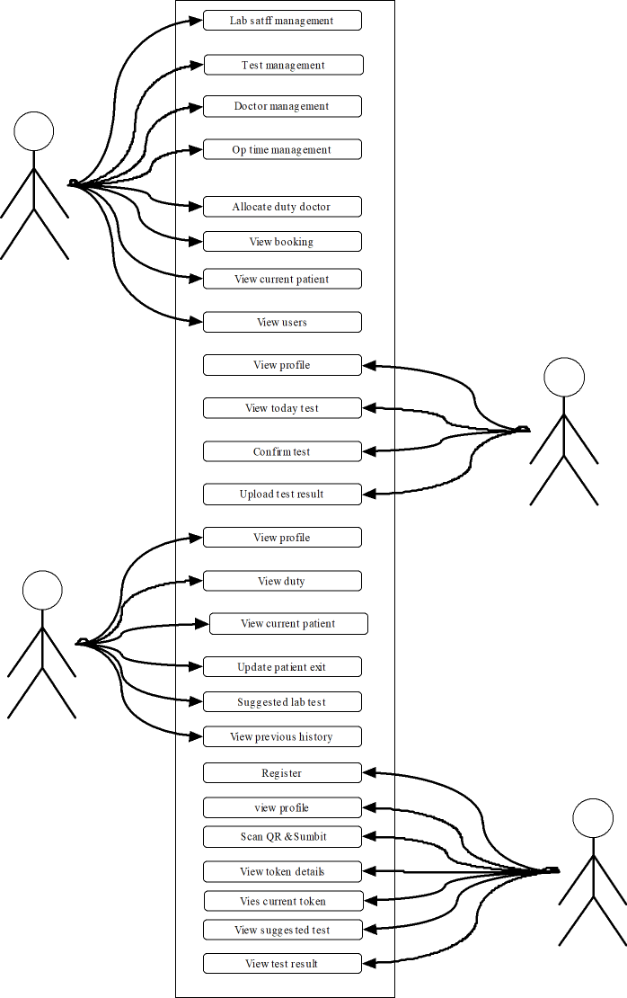

4.4 FEASIBILITY ANALYSIS
Preliminary investigations examine project feasibility, the likelihood the system organization. All projects are feasible-given unlimited resources and infinite time. Unfortunately, the development of a computer-based system or product is more likely plagued by a scarcity of resources and difficult delivery dates. It is both necessary and prudent to evaluate the feasibility of the project at the earliest possible time. Feasibility and risk analysis are related in many ways. Important tests of feasibility are studied and described below.
Technical Feasibility:
There are a number of technical issues, which are generally raised during the feasibility stage of the investigation. A study of function, performance and constraints that may affect the ability to achieve an acceptable system.
The considerations that are normally associated technical feasibility include:
- Development risk.
- Resource Availability.
3.Technology
Economic Feasibility:
Economic feasibility is an important task of system analysis. A system that can be developed technically and that will be used if installed must still be profitable for the organization. Financial benefits must equal or exceed the costs. The analyses raise financial and economic questions during the preliminary investigation to estimate the following:
1.The cost to conduct a full systems investigation
2.The cost of hardware and software for the class of application of the project being considered.
3.The benefits in the form of reduced costs or fewer costly errors.
4.The cost if nothing changes.
To be judged feasible, a proposal for the specific project must pass all these tests, otherwise it is not considered as a feasible project.
Operational Feasibility:
Proposed projects are beneficial only if they can be turned into information systems that will meet the operating requirements of the organization.This test of feasibility asks if the system will work when it is developed and installed. Maple properties satisfies all the operational conditions.
Legal Feasibility:
A determination of any infringement, violation, or liability that could result from
development of the system. Legal feasibility encompasses a broad range of concerns that include contracts, liability, infringement, and myriad other traps frequently unknown to technical staff.
Alternatives:
An evaluation of alternative approaches to the development of the system or product.The degree to which alternatives are considered is often limited by cost and time constraints; however, a legitimate but “unsponsored” variation should not be buried. The feasibility study may be documented as a separate report to upper management and included as an appendix to the system specification. The feasibility study is reviewed first by project management and upper management. The study should result in a “go/no-go” decision.

5.SYSTEM DESIGN

5.1 INTRODUCTION
System analysis is one of the important activities which are to be completed before starting the activities like designing, coding etc. If we will not do the Analysis part with ample importance or if we skip some functional areas of the system at the time of system analysis it is sure that the system developed by using the data obtained from that case not work in a proper way. Analysis is the first step towards solving the problem statement. It deals with devising a precise, concise, understandable and correct modal of the real system. Analysis helps to understand the requirements and the real-world environment in which the system will exist. The result of analysis should understand the problem as a preparation for design. The analysis model addresses the three aspects of the objects.
• Static structure
• Sequencing of interaction
. • Data transformations.
5.2 FUNDAMENTAL DESIGN CONCEPT
System design is the process of developing specifications for a candidate system that meet the criteria established in the system analysis -Major step in system design is the preparation of the input form and the output reports in a form applicable to the user. The main objective of the system design is to use the package easily by any computer operator. System design involves various stages as:
1. Data Entry
2. Transition
3. Communication
4. Search
5. Report
System Design is the creative act of invention, developing new inputs, a database, offline files, method, procedures and output for processing business to meet an organization objective. System design builds information gathered during the system analysis.

Requirement
Operation &
Maintenance
System and S/w Design

Implientation &
Unit testing

Integration&
System testing

• Requirement Analysis and definition
The system's services, constraints and goals are established by consultation with the system users. They are defined in a manner, which is understandable, by the users and development staff.
• System and software design
The system design process partitions the requirement to either hardware or software system. It establishes overall system architecture. Software design involves representing the software systems functions in a form that may be transformed in to one or more executable programs.
• Implementation and unit testing
During this stage,the software design is realized as a set of programs or program units.Unit testing involves that each unit meets its specification.
- Integration and system testing
The individual program units or programs are integrated and tested as a complete system to ensure that the software requirements have been met. After testing, the software system is delivered to the customer.
• Operation and maintenance
Normally this is the longest life cycle phase. The system is installed and put into practical use. Maintenance involves correcting errors which were not discovered in earlier stages of life cycle, improving the implementation of system units and enhancing the system's services as new requirements are discovered.

5.3 INPUT DESIGN
The input design is the process of converting the user-oriented inputs into the computerbased format. The data is fed into the system using simple interactive forms. Input data are collected and organized into a group of similar data. The forms have been supplied with messages so that user can enter data without facing any difficulty. The data is validated wherever it requires in the project. This ensures that only the correct data have been incorporated into the system. Inaccurate input data is me most common cause of data processing errors. Effective input design minimizes errors made by data entry operators.
The goal of designing input data is to make data entry as easy, logical and free from errors as possible. The proposed system has the input modules as
- Admin
- User
- Lab staff

5.4 OUTPUT DESIGN
A quality output is one, which meets the requirements of the end user and presents the information clearly. In any systems results of processing are communicated to the user and to other systems through outputs. Efficient and intelligent output design improves the system's relationship with the user and helps in decision-making.
Computer output is the important and direct source of information to the user. Efficient, intelligible output designs improve the system's relationships with the user and helps in decision making. They also provide a permanent hard copy of these results for later consultation.
The various types of output required by the system are:
- External output, whose destination is outside the concern and requires special attention
- Internal output, whose destination is within the concern and requires careful design because they are the user’s main interface within the computer
- Operation outputs, whose use is purely within the computer department, e.g., program listing, usage statistics etc.
- Interactive outputs, which involves the user in communicating directly with computers

5.5 DATABASE DESIGN
The overall objective in the development of database technology has been to treat data as an organizational resource and as an integrated whole. csdept.com allows data to protected and organized separately from other resources. Database is an integrated collection of data. The Database is an organized listing of all data elements that are pertinent to the system, with precise definitions so that both user and system analyst will have a common understanding of inputs, outputs, components of stores and intermediate calculations. There are 6 major steps in design process. The first 5 steps are usually done on paper and finally the design is implemented. Project’23 Prosgen-The promising generation BSc Computer Science NAM College Kallikkandy 30
- Identify the table and relationships
- Identify the data that is needed for each table and relationship
- Resolve the relationship
- Verify the design
- Implement the design

5.6 TABLE DESIGN
The overall objective in the development of database technology has been to treat data as an organizational resource and as an integrated whole. Database Management System allows data to be protected and organized separately from other resources. Database is an integrated collection of data.
This is the difference between logical and physical data.
The organization of data in the database aims to achieve three major objectives:
1. Data integration
2. Data integrity
3.Data independence
Normalization
The process of normalization is concerned with the transformation of the conceptual schema to a computer representable form. Normalization reduces the redundancies and anomalies.
The First Normal Form
First normal form does not allow multivalued and composite valued attributes. It states that the domain of an attribute must include only atomic values and that value of any attribute in a tuple must be single value from the domain of that attribute.
The Second Normal Form
In second normal form, for relations where primary key contains multiple attributes, non key attributes should not be functionally dependent on a part of the primary key.
Third Normal Form
In third normal form, relation should not have a non-key attribute functionally determined by another non-key attribute. That is there should be no transitive dependency of a non-key attribute on the primary key.
In Career Selection System, the tables are in third normal form (3NF). All tables satisfy all the
Conditions for third normal form. So there is no redundant data in the table.
There are two basic requirements for a database to be in third normal form:
• Already meet the requirements of both INF and 2NF
• Remove columns that are not fully dependent upon the primary key.
The first requirement is that the tables must satisfy the requirements of 1NF and 2NF. In the Motherland Seafood Management System any table does not contain duplicate columns and all tables have primary keys. Therefore, it satisfies the requirements of 1NF. There is no subset of data that apply to multiple rows. So we also satisfy the requirements of 2NF.
In each table each columns are fully depend on the primary key. So the tables satisfy the requirements of 3NF also.
The tables and field description used in this design are as follows

5.7 TABLES
1.TABLE NAME: login
primary key: login id
Column Name | Data Type | Description
Id | Int | Login id
username | Varchar(50) | User name
Password | Varchar(50) | password
Usertype | Varchar(50) | Type of user

2.TABLE NAME: doctor
primary key: doctor id
Column Name | Data Type | Description
Id | Int | Doctors id
Name | Varchar(50) | Doctors name
Email | Varchar(50) | Doctors email
Phone | Int | Doctors phone
Specialization | Varchar(50) | Doctors specialization
Qualification | Varchar(50) | Doctors qualifications
Image | Varchar(50) | Doctors image
Login_id | Int | Doctors login id

3.TABLE NAME: lab staff
primary key: lab staff-id
Column Name | Data Type | Description
Id | Int | Lab staff id
Name | Varchar(50) | Lab staff name
Email | Varchar(50) | Lab staff email
Phone | Int | Lab staff Phone
Login_id | Int | Lab staff login id
Image | Varchar(50) | Lab staff image

4.TABLE NAME: test
primary key: test id

Column Name | Data Type | Description
Id | Int | Test id
Test name | Varchar(50) | Test name
Description | Varchar(50) | Test description
Amount | Int | Test amount
Waiting time | Int | Test result waiting time

5.TABLE NAME: op time
primary key: op time id

Column Name | Data Type | Description
Id | Int | Optime id
Date | Date | Op date
From_time | Varchar(50) | Op fromtime
To_time | Varchar(50) | Op totime

6.TABLE NAME: duty allocation
primary key: duty allocation id

Column Name | Data Type | Description
Id | Int | Allocation id
Doctor_id | Int | Doctor id
Optime_id | Int | Optime id

7.TABLE NAME: bookings
primary key: bookings id
Column Name | Data Type | Description
Id | Int | Booking id
Date | Date | Booking date
Time | Varchar(50) | Booking time
Token | Int | Token no
Status | Varchar(50) | Booking status
Optime_id | Int | Optime id
Users_id | Int | User id

8.TABLE NAME: current patient
primary key: current patient id

Column Name | Data Type | Description
Id | Int | Current patient id
Status | Varchar(50) | Patient status
Booking_id | Int | Bookings id
Duty_allocation-id | Int | Duty allocation id

9.TABLE NAME: users
primary key: users id

Column Name | Data Type | Description
Id | Int | Users id
Name | Varchar(50) | User’s name
Email | Varchar(50) | User’s email
Phone | Int | User’s phone
Gender | Varchar(50) | User’s gender
Age | Int | User’s age
Login_id | Int | Users login id

10.TABLE NAME: today test
primary key: today test id

Column Name | Data Type | Description
Id | Int | Test id
Status | Varchar(50) | Test status
Bookings_id | Int | Bookings id
Doctors_id | Int | Doctors id
Test_id | Int | Test id

11.TABLE NAME: test result
primary key: test result id

Column Name | Data Type | Description
Id | Int | Test result id
File | Varchar(50) | Test result
Today_test_id | Int | Today test id

12.TABLE NAME: Bank
Primary key:
Column Name | Data Type | Description
Id | Int | Bank id
Bank | Varchar(50) | Bank name
Acc | Int | Account number
Pin | Int | Pin number
Balance | Int | Account balance

5.7 CONCEPTUAL SYSTEM DESIGN
After study and the analysis of the existing system the functional operational requirements were identified. Based on these requirements the conceptual model of the system is designed. The objective of the system design is to improve the existing system or design a new system with improved facilities.
Data Flow Diagram:
Data Flow Diagrams is the best and easiest tool to represent the flow of the data in the project. It is otherwise known as a bubble chart. It has the purpose of clarifying system requirements and identifying major transformations that will become programs in System design. It is the major starting point in the design phase that functionally decomposes the requirements specifications down to the lowest level of detail. A DFD consists of a series of bubbles joined by lines. The bubble represents data transformation and lines represent data flow in the system. In the normal convention a DFD has four major symbols.
Square, this defines source or destination of data

Arrow, which shows data flow

Circle, which represents a process that transforms incoming data into outgoing flow

Open rectangle, which shows a data store

A DFD model of a system graphically depicts the transformation of the data input to the system to the final result through a hierarchy of levels. The DFD at the simplest level is referred to as the ‘zero level DFD’ or in simple words a ‘Context Analysis Diagram’. These are expanded level by level each explaining its process in detail. Processes are numbered for easy identification and are normally labelled in block letters. Each data flow is labelled for easy understanding

DFD

Level 0
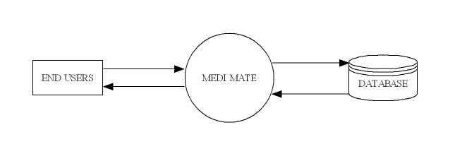

Level 1
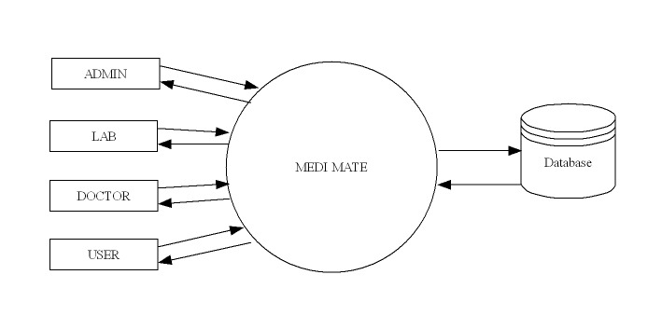

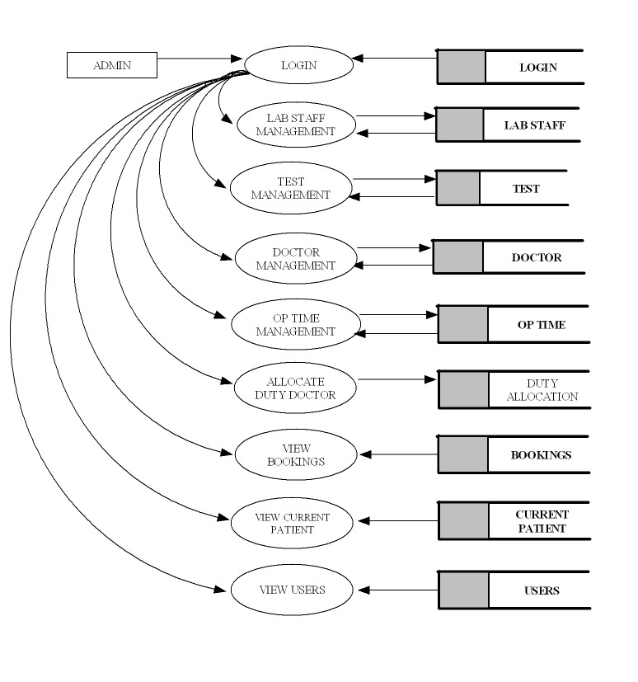
Level 1.1 ADMIN

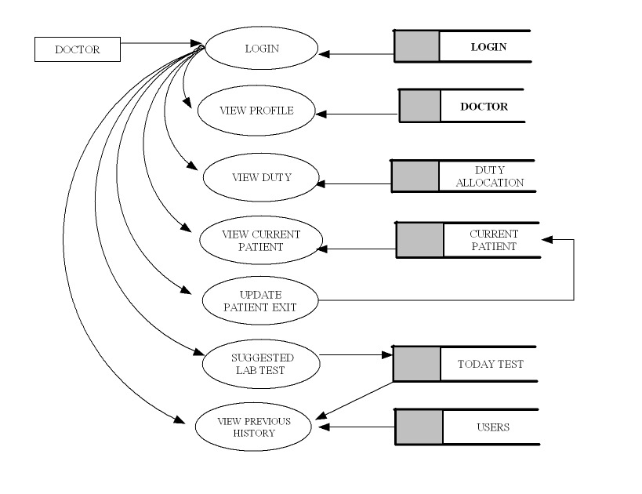
Level 1.2 DOCTOR

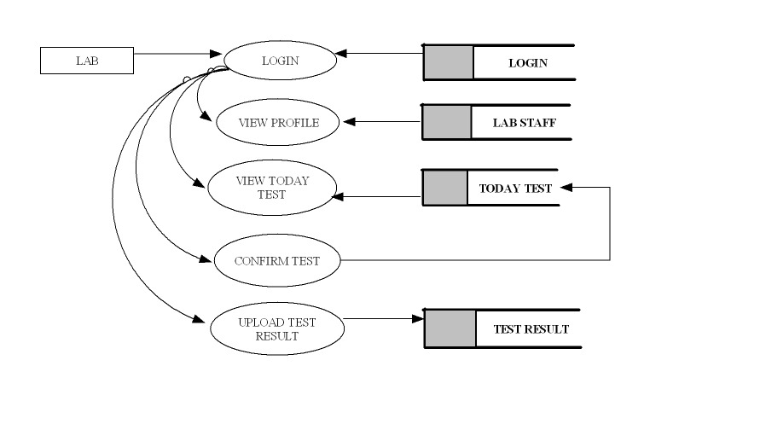
Level 1.3 LAB STAFF

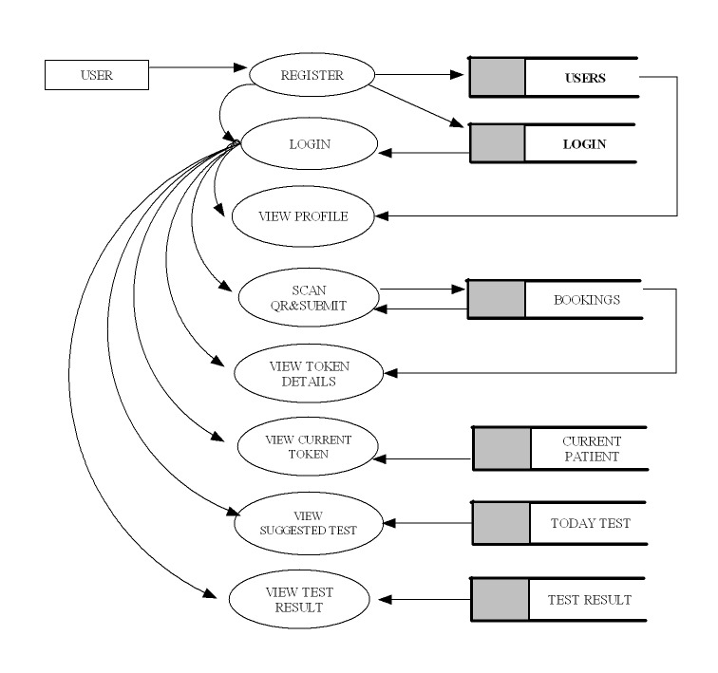
Level 1.4 USER

5.8 VALIDATION AND CHECKS
Software validation is achieved through a series of tests that demonstrate conformity with requirements. Validation succeeds when software functions in a manner that can be reasonably expected by the customer. Here used line by line checking for to find errors. Comment line facility is used for checking errors. Testing is necessary for the success of the system. During testing, a program to be tested is executed with a set of test data and the output of the program for test data is evaluated to determine if the programs are performing as expected. Validation means checking the quality of software in both simulated and live environments. System validation ensures that the user can in fact match his/her claims, especially system performance. True validation is verified by having each system tested. First the application goes through a phase often referred as alpha testing in which the errors and failures based on simulated user requirements are verified and studied. The modified software is then subjected to phase two called beta testing in the actual user’s site or live environment. After a scheduled time, failures and errors are documented or final correction and enhancements are made before the package is released.

6.SYSTEMDEVELOPMENT

System development is a series of operations performed to manipulate data to produce output from a computer system. This highly depends on the programming language used. Programming techniques include the concept of "object-oriented programming." Object-oriented programming centers on the development of reusable program routines (modules) and the classification of data types (numbers, letters, dollars, etc.) and data structures (records, files, tables, etc.). Linking pre-scripted module objects to predefined data-class objects reduces development times and makes programs easier to modify. The development phase involves converting design specifications into executable programs. Effective development standards include requirements that programmers and other project participants discuss design specifications before programming begins. The procedures help ensure programmers clearly understand program designs and functional requirements. The principle activities performed during the development phase can be divided into two major related sequences. They are:
- External system development.
- Internal system development.

The major External system development activities are:
- Implementation
- Planning
- Preparation of manual
- Personal training
- Equipment acquisition
- Installation

The major system internal development activities are:
- Computer program development
- Performance testing

7.SYSTEM CODING ANDTESTING

7.1 SYSTEM TESTING
Testing is finding out how well something works. In terms of human beings, testing tells what level of knowledge or skill has been acquired. In computer hardware and software development, testing is used at key checkpoints in the overall process to determine whether objectives are being met. Testing is a process used to help identify the correctness, completeness and quality of developed computer software. With that in mind, testing can never completely establish the correctness of computer software. Testing helps in verifying ad validating if the software is working as it is intended to be working. For example, in software development, product objectives are sometimes tested by product user representatives. When the design is complete, coding follows and the finished code is then tested at the unit or module level by each programmer; at the component level by the group of programmers involved; and at the system level when all components are combined together.

Black box testing
It takes an external perspective of the test object to derive test cases. These tests can be functional or non-functional, though usually functional. The test designer selects valid and invalid inputs and determines the correct output. There is no knowledge of the test object's internal structure. This method of test design is applicable to all levels of software testing: unit, integration, functional testing, system and acceptance. The higher the level, and hence the bigger and more complex the box, the more one is forced to use black box testing to simplify. While this method can uncover unimplemented parts of the specification, one cannot be sure that all existent paths are tested.

White box testing
An internal perspective of the system to design test cases based on internal structure. It requires programming skills to identify all paths through the software. The tester chooses test case inputs to exercise paths through the code and determines the appropriate outputs. While white box testing is applicable at the unit, integration and system levels of paths within a unit, it can also test paths between units during integration, and between subsystems during a system level test. Though this method of test design can uncover an overwhelming number of test cases, it might not detect unimplemented parts of the specification or missing requirements, but one can be sure that all paths through the test object are executed. Several testing methods are present to ensure the quality of Online Identity.

7.2 LEVELS OF TESTING
Unit Testing:
Unit testing focuses verification effort on smallest unit of software design module. Here, there are three module namely, Admin System, Teacher System, Module System.
In unit testing:
- Module interface is tested to ensure that information properly flows into and output of the program under test.
- Local data structures are examined to ensure that data stored temporarily maintains its integrity during all steps in algorithm execution Boundary condition is tested to ensure that the module operates properly at boundaries established to limit or restrict processing.
- All independent paths through the control structures are executed to ensure that all statements in the module have been executed at least once.
- Error handling paths are also tested.
Unit testing focuses verification effort on the smallest unit of software design, the module. Here, the module interfaces, local data structure, boundary conditions, and all independent paths and last but not the least, all error handling paths were verified by inputting false data. Tests of data flow across each module interface of this software were done before any other test was initiated.

Integration Testing:
Integration testing is a systematic technique for constructing the program structure while at the same time conducting tests to uncover errors associated with interfacing. Unit tested module were taken and a single program structure was built that has been dictated by the design. Incremental integration has adopted here. The entire software was developed and tested in small segments, where errors were errors were easy to locate and rectify. Program builds (group of modules) were constructed corresponding to the successful testing of user interaction, data manipulation analysis, and display processing and database management.
There are two strategies of Integration testing.
- Top-down integration
- Bottom-up integration

Validation Testing:
Validation testing is done to ensure complete assembly of the error-free software. Validation can be termed successful only if it functions in manner that is reasonably expected by the customer.
Under Validation test:
- Alpha testing
- Beta testing
Alpha testing is where the end user tests the system rather than the developer, but in a controlled environment. The software is used on a natural setting with the developer monitoring the user using the system. The developer records the errors and usage problems encountered by the user.
The sales person conducts beta testing at one more sites. The developer is not present during the tests. Hence, beta test can be said as the live application of the software on an environment that cannot be controlled by the developer. The sales person takes down the problems encountering during beta testing and reports these to the developer at regular intervals. The developer makes suitable modifications of the software henceforth.

System Testing:
System testing is actually a series of different tests whose primary purpose to fully exercise the computer-based system. Each test works to verify that all system elements have been properly integrated.
Types of system tests are:
- Recovery Testing
- Security Testing
- Stress Testing.
- Performance Testing

7.3 TESTING THE SYSTEM
The test team of College Information through Mobile consists of the college Teacher, the Student and myself. We test the system by running it in several ways by inputting various values in the respective forms.
The main concerns in our testing are following:
- Browse compatibility: This test validates consistent applications performance on variety of browser type and configuration.
- Functional correctness: These tests validates that the application function correctly.
- Integration: These test the integration between browsers and servers, applications and data, hardware and software.
- Usability: These test the overall usability of a web page or a web application, including appearance clarity and navigation.
- Security: These test the adequacy and correctness of security controls including access control and authorizations.
- Performance: These test the performance of the web applications under load.
- Verification of codes: This validate that the code used in building the web application has been used in a correct manner.

8.SYSTEMIMPLEMENTATION

SYSTEM IMPLEMENTATION
Crucial phase in the systems life cycle is the successful implementation of the new system design. Implementation means converting a new system into operation.
In the implementation phase, the team builds the components either from scratch or by composition. Given the architecture document from the design phase and the requirement document from the analysis phase, the team should build exactly what has been requested, though there is still room for innovation and flexibility. For example, a component may be narrowly designed for this particular system, or the component may be made more general to satisfy a reusability guideline. The architecture document should give guidance. Sometimes, this guidance is found in the requirement document the implementation phase deals with issues of quality, performance, baselines, libraries, and debugging. The end deliverable is the product itself.
Implementation is an application, execution of an idea, plan, model, specification, design, standard, policy and algorithm. Project Implementation process may be effective if some very important factors are kept in mind that are urgent in a project management system. It is crucial for everyone to start the project by keeping in mind some factors are identified in the article. Implementation of a project is the step where all the proper planned activities are put into action. Before starting the implementation of a project, the implementers must identify his weaknesses and strength. The customer's needs from the product of the project must be defined, and the project scope should be clearly known. Keep a record of when the project implementation process starts and finishes. The main thing to do before the implementation of a project is to predetermine and discuss the project budget and the estimated time, and the manpower required to finish the project.
To ensure successful project implementation, there are some important tips that you need to make use of. The project should have people who are dedicated more to create the situations of the successful project implementation. Before the project implementation process starts, ensure you have all factors of project process written or recorded on paper. This will make the project implementation process easier to manage, and they can be of used for the projects that are the same as the current project. Project monitoring is also an important thing to make sure that activities are implemented as per planned. This assists the project implementers to check how well they are getting their objectives. This process is fully based on the knowledge that the procedure, by which a project is implemented, has so many effects on its access, maintenance, and operation.
When you are looking for a project implementation process, the implementation process begins and includes many different phases. The first starts with project planning phase that wants you to plan your tasks of the project. The second one is the project design phase that consists of the creation of system design comprising of application designing, database designing and the data communication design. The other phases in the project implementation process consists of create and unit test phase, integration test phase, training phase, and finally, the close out phase. The project implementation process needs urgent pre requisites identified above in the article to make the project a success and reliable. The “Medimate” created can be implemented by first uploading it to the internet and can be made useful to the users.

9.SYSTEMEVALUATION

9.1 SYSTEM EVALUATION

The options or facilities that have been included in the system are user friendly and up to the mark. The burden of the authority for many tedious tasks have been reduced to a great extends. The main advantage of the software being that it can be reconstructed as of desired format for the requirement rises from time to time. This makes it beneficiary not to think about a second one at a later stage. As a whole can be concluded that the system has met the needs of the developing authority to a great extend.
Various approaches of system evaluation that have been carried out to maintain the system performance are as follows.

- Requirement Analysis
- Criteria Definition
- Testing and Verification
- Comparative Analysis
- Feedback Collection
- Documentation and Reporting

10.FORMS

Home Page:
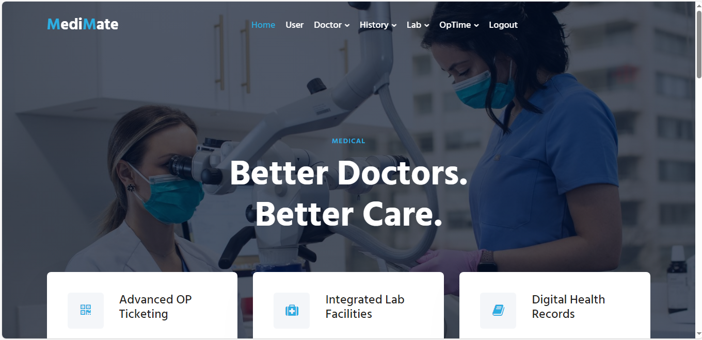

Profile page:

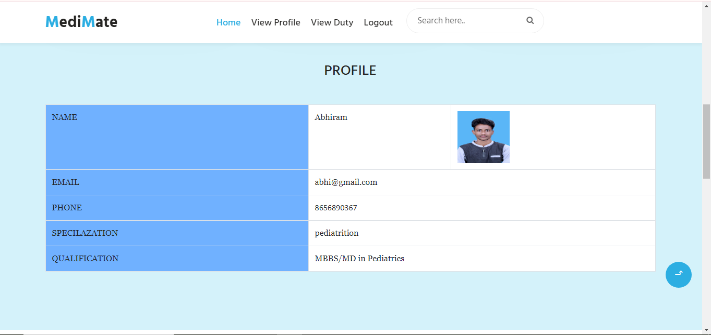

Doctor Page:
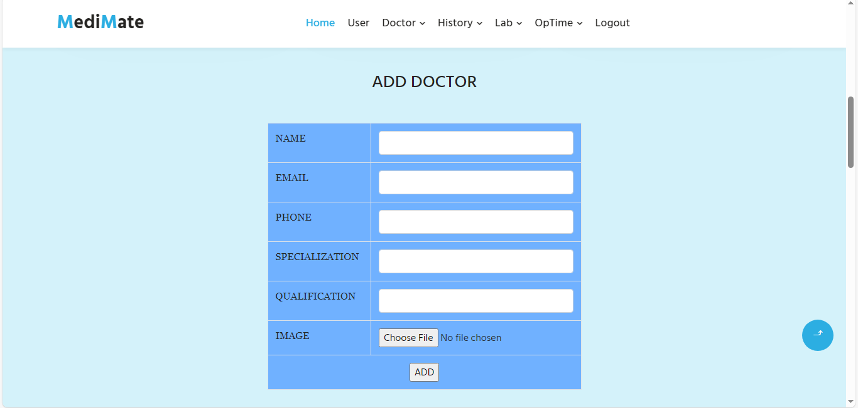

Patient Page:

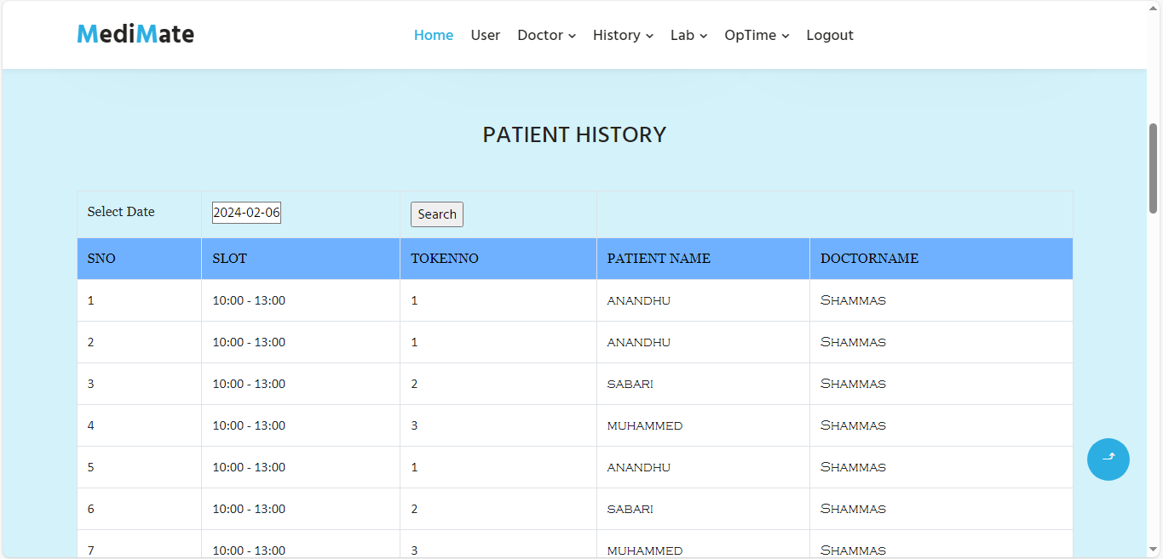

OP Time Page:
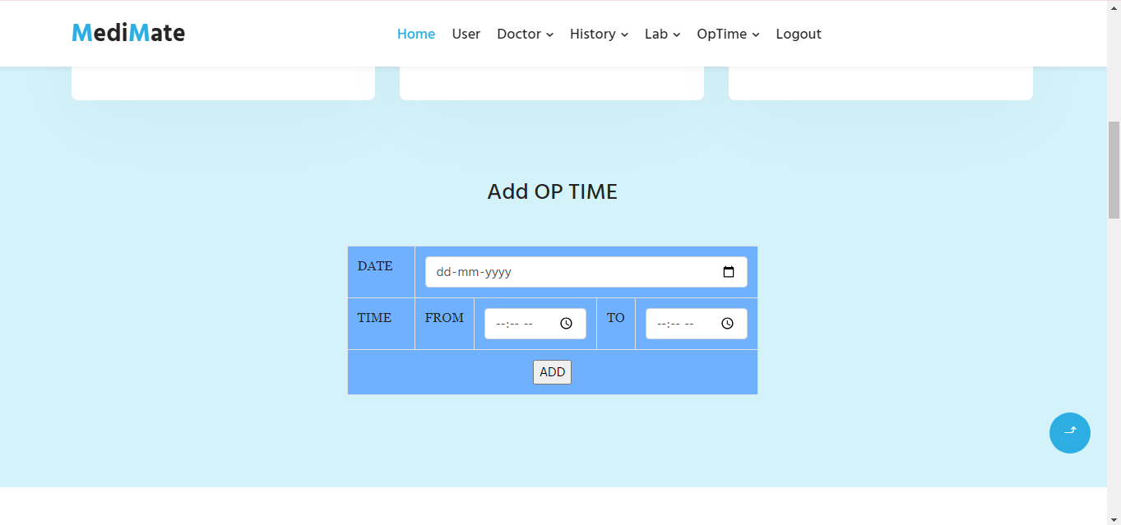

Patient details:

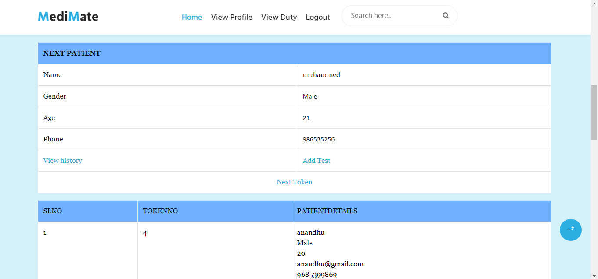

Op time:

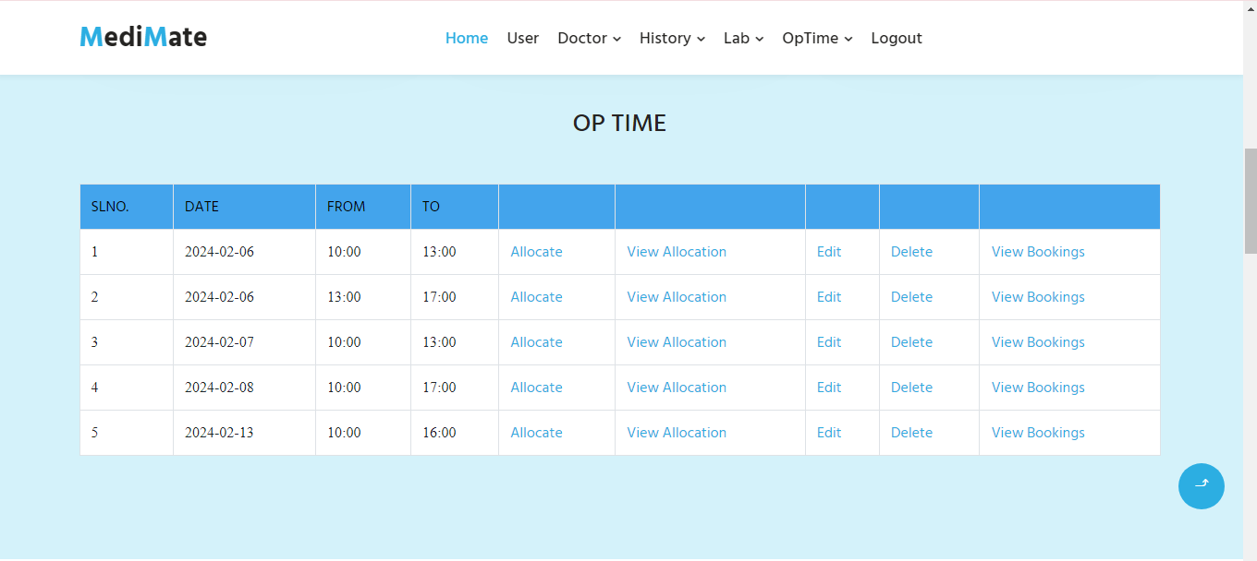

Doctors: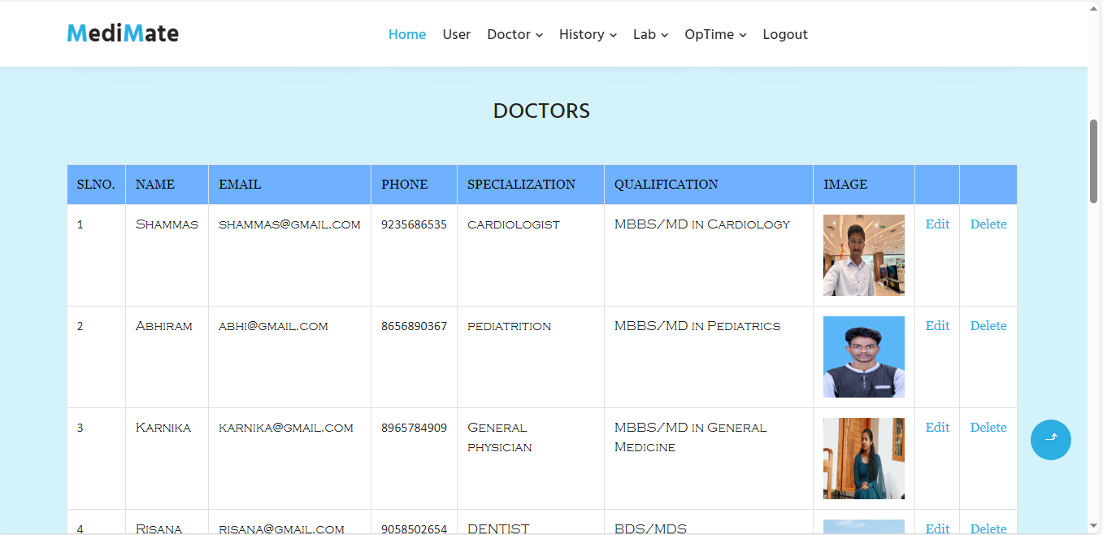

11. CONCLUSION
Conclusion is the summing up of arguments described in this article. This software provides a user-friendly approach towards the system. This system has been well developed and when implemented, is bound to satisfy all of the requirements. Painstaking efforts have been taken to make the software impeccable and upgradeable. There is a hope that this software will be utilized to its maximum and will do a good job in the long run. With blessings of God, the exertions are hoped to bear fruit. The program for carrying out various activities have been run and successfully tested to ensure that the software developed meets the needs satisfactorily. Any users can process the Online PROSGEN-THE PROMISING GENERATION without any experience in any software products. The major advantages of software products are:
- Fast retrieval of entries from database
- Cost effective.
- Quick implementation results.
- Available in diskette.
- Convenience,
- Ubiquity.
The software was developed in HTML, PYTHON and SQL.it is expected to live up to the objectives for which it was designed.
The primary objective of this project “MEDIMATE” is providing a healthy young generation. Students are treasures of our world and we are trying to protect those treasures. The drawbacks of the system were analyzed and carefully studies. The new system was designed and its reusability checked at later stage. Beside the security provides by the window additional security has been built into the system.
System has been successfully tested and implemented with running on different computers and it is seen that the system has high degree of accuracy and user friendliness.
The system is a user-friendly system and further changes can be incorporated into the system easily.

